Development of an AI Solution for Surgical Gauze Management



DING JISHEN

SCHOOL OF MECHANICAL AND AEROSPACE ENGINEERING   
NANYANG TECHNOLOGICAL UNIVERSITY

2022/2023

Project No. C006

**Development of an AI Solution for Surgical Gauze Management**

**Submitted By: Ding Jishen**

**Supervisor: Associate Professor Cai Yiyu**

SCHOOL OF MECHANICAL AND AEROSPACE ENGINEERING   
NANYANG TECHNOLOGICAL UNIVERSITY

A Final Year Project report presented to Nanyang Technological University in partial fulfilment of the requirements for the Degree of Bachelor of Engineering (Mechanical Engineering)

**2022/2023**

# Abstract

Surgical procedures often require the use of gauze to prevent bleeding and infections, but manual gauze counting can be time-consuming, prone to error, and pose a potential threat to patient safety if any gauze is left inside a patient. This project developed an automated system for detecting and counting surgical gauze during surgery to address the challenge. Two hardware frames were designed to hold the camera and processor ensure the system's stability and usability in the operation theatre environment. The development of an automatic counting software and user interface, which eliminated the need for human input. In addition, a human detection function was integrated into the system to prevent human error. Over 1000 raw data points were collected, and three representative AI models (GauzeV5, GAUZEBW, GAUZECOLOR) were trained based on the YOLOv5 object detection algorithm are discussed in this report. The models were evaluated using precision, recall, F1 score, and mAP@0.5, with GauzeV5 performing well in detecting clean gauze, but failing to detect blooded gauze in real-world testing. GAUZEBW and GAUZECOLOR models performed better in detecting blooded gauze, but at the cost of sacrificing some confidence levels in detecting clean gauze. Overall, the choice of model depends on the specific application condition and the trade-off between detection accuracy and computational resources.

This project demonstrates the feasibility of a gauze counting product that can improve surgical efficiency and reduce the risk of leaving gauze inside patients. The proposed system provides a foundation for the development of a reliable gauze management product for use in real-world surgical settings. By automating the gauze counting process, the system can potentially save time and reduce the risk of human error. Future works are suggested at the end of this report.

# Acknowledgements

I would like to express my sincere gratitude to Professor Cai Yiyu for his invaluable guidance and support throughout this project. His insights and expertise have been instrumental in the development of this system.

I would also like to thank Dr. Luke and Mr. Aaron Tham from the Singapore General Hospital for their valuable feedback and contributions to this project. Their expertise in the field of surgical procedures has been critical to the success of this system.

In addition, I would like to acknowledge Mr. Abu and Yunfai for their assistance in solving technical issues during the development of the system.

Finally, I would like to thank JunHoe, Zaheen, and Bach, year 2 students doing their URECA program, for their help in the project. Their contributions and dedication have been invaluable in the development of the system.

I am grateful for the support and encouragement of all those who have contributed to this project, and I am excited to continue working on this important area of research.

Table of Contents

Abstract iii

Acknowledgements iv

List of Figures viii

List of Tables x

Chapter 1 Introduction 1

1.1 Background 1

1.2 Current Methodology 1

1.3 Objective 2

1.4 Scope of Work 2

Chapter 2 Literature Review 3

2.1 Gauze Detection using Computer Vision 3

2.2 Previous Studies by NTU 4

2.3 Material Consideration in Operation Theatre 6

2.3.1 Metal Parts 7

2.3.2 Non-metal Parts 8

2.4 Relevant AI models 10

2.4.1 SSD MobileNet 10

2.4.2 You Only Look Once (YOLO) 10

2.4.3 U-Net 11

2.4.4 Comparison 11

Chapter 3 IGauze Hardware design 13

3.1 Conceptual Design 13

3.1.1 Function Analysis 13

3.1.2 Design Concepts 14

3.2 Embodiment Design 19

3.2.1 Design 1 with edge device 19

3.2.2 Design 2 with PC 23

Chapter 4 IGauze Software Design 27

4.1 Set-Up of environment 27

4.2 Data preparation 30

4.2.1 Raw images collection 30

4.2.2 Image Pre-processing and Augmentation 32

4.3 AI Model Training 34

4.4 Process Flow 35

4.5 UI design 37

Chapter 5 Result and Discussion 37

5.1 Testing method 37

5.2 Evaluation of AI model 39

5.3 Current limitation 41

Chapter 6 Conclusion 41

6.1 Contribution 41

6.2 Future Work 42

Reference 43

# List of Figures

Figure 1: Prototype by Mr. Ang Soon Kim 6

Figure 2: Prototype by Mr. Lee Yun Fai 7

Figure 3: Operation flow chart 15

Figure 4: Automated Conveyor Concept 16

Figure 5: Tray-based Conveyor Concept 17

Figure 6: Desk Lamp Concept 18

Figure 7: Drip Stand Concept 19

Figure 8: Drip Stand Concept Final Design 21

Figure 9: Led Light On The Real Product 22

Figure 10: (A) Handle, (B) Gripping Mechanism 22

Figure 11: Semi S8-0218 Section 2.4 23

Figure 12: Semi S8-0218 Section 8.1.1 23

Figure 13: (A) Actual Prototype, (B) Prototype in Hospital 24

Figure 14: Components In PC Version Design 25

Figure 15: PC Version Final Design 26

Figure 16: CUDA Version Checking 29

Figure 17: CUDA Installation Status 30

Figure 18: PyTorch Version Checking 31

Figure 19: Raw Data Samples 32

Figure 20: Sample Set Up For Data Collection 33

Figure 21: Software Process Flow 37

Figure 22: UI Design 38

Figure 23: Testing in PC 39

Figure 24: Real-World Testing 40

# List of Tables

Table 1: Comparison between AI models 13

Table 2: Summary of Model Trained 34

Table 3: YOLOv5 Weight Specification 35

Table 4: Model Result 41

# Chapter 1 Introduction

## Background

The rapid developments of medical technology are revolutionizing surgical equipment to become more advanced than ever before. However, the incidence of retained surgical items (RSIs) still occurs worldwide every year. The most common RSIs are surgical gauzes.[1] As gauzes are essential supplies to absorb blood and clean wounds in surgery, 80% of the RSIs cases are made up by them.[2] For such cases, they are described as ‘Gossypiboma’. Although the reported rate of gossypiboma is usually as low as once in every 3000 to 5000 surgical operations [3], the real number is unknown and varies among studies due to the sensitive nature of the incidents. The complications of gossypiboma could cause an increase in morbidity, mortality, and financial burden to the patients. For the surgeon and nurse, it is would be a source of mental agony, reputational loss, humiliations, financial loss, and imprisonment.[4]

Therefore, it is necessary to find a method to help surgeons and nurses perform their jobs with lesser mistakes, as well as provide the patient with a safer surgical environment.

## 1.2 Current Methodology

Currently, there are 3 methods that have been used to prevent gossypiboma: manual counting of gauzes, uses of RFID gauzes and uses of X-ray detectable gauzes.

Some of the hospitals had established their own standard operating procedure (SOP) to count the gauzes manually before and after the surgical operation. However, this method still could result in an unacceptably high accident rate. For instance, a study from Japan Council for Quality Health Care shows from January 1, 2016, to March 31, 2019, there were 57 cases of gossypiboma, despite a gauze count being performed before and after the operation. The gauze count matched in 48 of those cases.[5] Although the method may reduce the accident rate, it is difficult to eliminate human errors even with an SOP.

High-technology gauzes like RFID and X-ray detectable gauzes could eliminate human errors, but the cost is about 50 to 10 times of normal gauzes.[6] As gauzes are consumables, this will not be suitable for patients from different financial backgrounds.

## 1.3 Objective

The objective of this project is to develop a proof-of-concept gauze counting system including both software and hardware for use in the operating theatre. The system will use AI technology to detect and count surgical gauze in real-time, reducing the risk of retained surgical items (RSIs) and improving patient outcomes. The system will also include a human detection module to reduce the risk of human error and improve the accuracy of gauze counting. The project aims to demonstrate the feasibility of using AI technology to improve surgical safety and efficiency, paving the way for the development of a commercial product that can be used in hospitals and medical centres.

## 1.4 Scope of Work

The scope of work for this project involves a thorough review of existing literature and technologies related to gauze detection using computer vision and materials that suitable for equipment used in an operation theatre. This will be followed by the design and development of a hardware frame that can accommodate the required components and functions. The next step will be the development and training of an object detection algorithm using YOLOv5, with a particular focus on detecting and automatic counting surgical gauze in real-time.

Once the object detection algorithm is trained, it will be integrated with the hardware frame to create a working gauze counting system. Testing and validation of the system's accuracy and performance will be carried out to evaluate its ability to detect and count gauze in real-time, as well as its ability to distinguish between gauze and other objects in the operating theatre. Throughout the project, documentation of the design and development process, as well as testing results, will be kept.

The final step will involve concluding the project findings and recommendations for future development and improvement of the gauze counting system.

# Chapter 2 Literature Review

## 2.1 Gauze Detection using Computer Vision

Recently, computer vision techniques, especially deep learning-based methods, have gained significant attention for the purpose of detect and count of gauze materials in surgical procedures. Several studies have been conducted on the automatic detection of surgical gauzes using computer vision techniques. This section reviews some of the recent works on gauze detection and counting using computer vision.

In June 2015, Álvaro García-Martínez and the team proposed a computer vision approach for detecting surgical gauzes left inside patients after surgery. The proposed method uses a texture-based approach, an algorithm modified based on Local Binary Pattern (LBP) to identify gauze areas in the images acquired by the laparoscopic camera. It was able to distinguish between gauze pixels and background pixels in the surgical scene with a sensitivity of 42.95% and a specificity of 90.88%. [7]

Another paper titled ‘Automatic gauze tracking in laparoscopic surgery using image texture analysis’ by Eusebio de la Fuente López and the team tried both Local Binary Pattern (LBP) and Convolutional Neural Network (CNN) approach. The proposed LBP algorithm achieves a robust detection of gauzes with 98% precision and 94% sensitivity. And the CNN approach also yields superior results with 100% precision and 97% sensitivity, but real-time processing is not feasible with standard hardware. [8]

More recently, in 2022, Guillermo Sánchez-Brizuela and the team uses 4003 hand-labelled images from laparoscopic videos that contain surgical gauze to train varies CNN models. The paper reports that the best method for gauze segmentation is a U-NET-BASED architecture that achieves an intersection over union of 0.85 and runs above 30 fps. Another model they tested was Yolov3, the results revealed it can also be executed in real time but provides a modest recall. [9]

Overall, gauze detection and counting using computer vision techniques has received significant attention in recent years. Deep learning-based methods, especially CNN-based methods, have shown superior performance compared to traditional methods such as the LBP algorithm mentioned above. And because of the natural of the gauze the shape and colour is not consistence the texture-based detection will be critical in the recognition.

## 2.2 Previous Studies by NTU

Besides the work done by other schools’ researchers. There were two studies from NTU as well.

The first study was made by Mr. Ang Soon Kim shows in figure 1. He developed a system that reformatted the dataset to COCO format, allowing for reuse by future researchers, and made the program executable on Google Colab for wider accessibility. He also built a mobile application that housed the AI model based on MobileNet-v2 to perform gauze counting and communicated the data through Bluetooth and Wi-Fi. The system was prototyped using the software as the base and could be connected to other systems. [10]

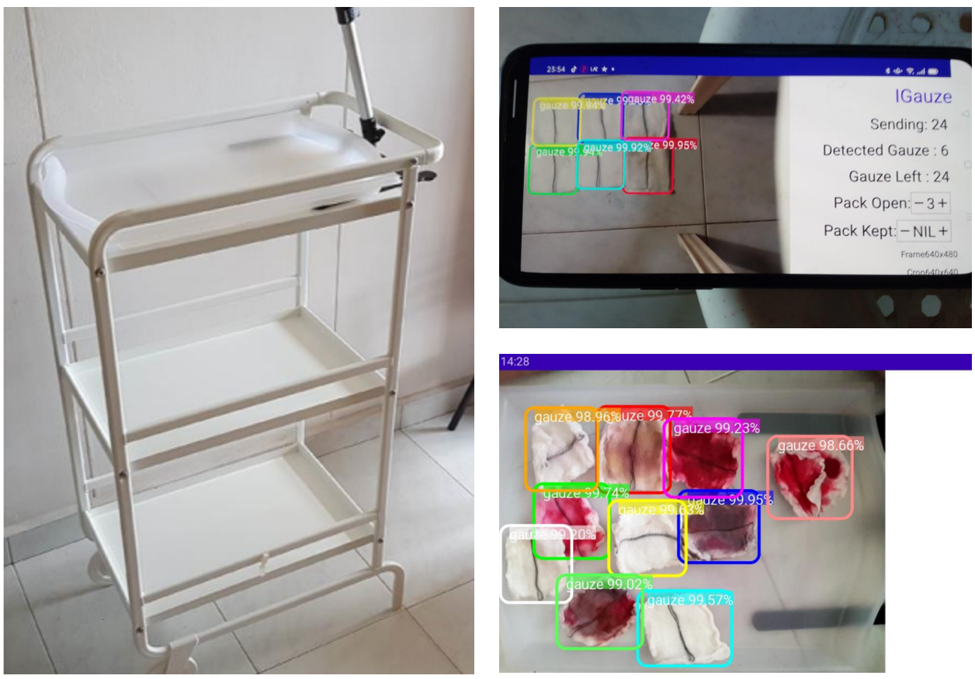

Figure 1: Prototype by Mr. Ang Soon Kim

Another study done by Mr. Lee Yun Fai shows in figure 2. He developed a system that leveraged a Raspberry Pi Zero with a camera to remotely access the system via the internet. And used a Jetson Xavier NX development kit with another camera as main processer to process the two videos collected by both cameras. Most of the gauze annotation was done on CVAT, an open-source online platform capable of exporting in most popular computer vision annotation formats. As well as a user interface and interactions with the system were designed to ensure maximal intuitiveness, essential for quick adoption by medical professionals. [11]

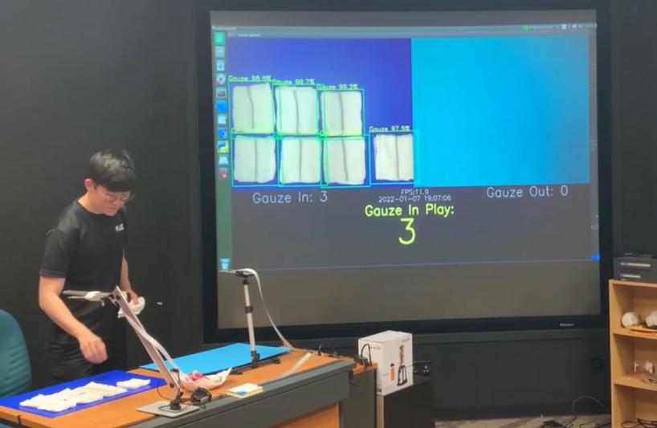

Figure 2: Prototype by Mr. Lee Yun Fai

These previous studies provide insights into the development of a gauze detection system using computer vision techniques. Both have demonstrated promising results in detecting and accounting for surgical gauzes. The dataset and intuitive user interface were still being used in this study.

However, both developments require human input in the form of pressing a button or touching the screen, which may not be practical in the sterile environment of the operation theatre. Furthermore, for a system solution hardware frame was lacked in the previous studies. These problems will be solved in this study.

## 2.3 Material Consideration in Operation Theatre

An operating theatre, also known as an operating room, is a specialized facility used for performing surgical procedures on patients. The environment in an operating theatre is carefully controlled to ensure a sterile and safe environment for both the patient and the surgical team. The materials used in an operation theatre are crucial to maintaining a sterile environment and preventing infection.

### 2.3.1 Metal Parts

Operation theatres are highly sensitive environments where precision, accuracy, and safety are paramount. To ensure optimal outcomes and reduce the risk of infection, equipment used in operation theatres needs to be made from high-quality, durable materials that can withstand the rigors of repeated use and frequent cleaning. Metal materials have proven to be an excellent choice for the development of operation theatre equipment due to their strength, durability, and resistance to corrosion.

Stainless steel is the most commonly used metal in operation theatre equipment. This is due to its excellent strength, durability, and resistance to corrosion. Stainless steel is also easy to clean and sterilize, making it an ideal choice for surgical instruments, tables, and trays. There are two types of stainless steels that widely used in various application SUS304 and SUS316. The main difference between SUS304 and SUS316 is their composition. SUS304 contains 18% chromium and 8% nickel, while SUS316 contains 16% chromium, 10% nickel, and 2% molybdenum. [12] The addition of molybdenum in SUS316 improves its corrosion resistance, making it more resistant to acidic and corrosive environments compared to SUS304. Due to its superior corrosion resistance, SUS316 is often used in medical devices and implants that require high levels of biocompatibility and resistance to corrosion, such as pacemaker cases, orthopaedic implants, and dental instruments. On the other hand, SUS304 is commonly used in surgical instruments, medical equipment, and hospital furnishings where corrosion resistance is not a primary concern, but durability and ease of cleaning are important factors. [13]

Another metal that has gained popularity in operation theatre equipment development is titanium. Titanium is a lightweight metal that is highly resistant to corrosion and has excellent strength. It is also biocompatible, which means that it does not cause an adverse reaction when it comes into contact with human tissue. As a result, titanium is commonly used in the development of orthopaedic implants as well, such as hip replacements and spinal implants. [14]

In recent years, there has been an increased interest in the use of magnesium alloys in operation theatre equipment development. Magnesium alloys are lightweight and have excellent strength, making them an attractive alternative to stainless steel and titanium.[15] Additionally, magnesium alloys have good biocompatibility and can be easily moulded into complex shapes, making them an ideal material for surgical tools. [16]

Aluminium 6061 is also a commonly used alloy in various industries including aerospace, automotive, and construction. While it is generally considered a safe and reliable material, its use in an operating theatre would depend on the specific application and requirements. In general, aluminium 6061 may not be the ideal material for equipment used in an operating theatre due to concerns over its corrosion resistance to certain chemicals or substances and potential for bacterial growth. However, it can be considered for prototyping and those noncritical parts due to it is price and ease of machining. [17]

### 2.3.2 Non-metal Parts

Many non-metal materials are used in the development of equipment for the operation theatre due to the many benefits that non-metal materials offer, such as reduced weight, increased durability and better resistance to corrosion, chemicals and heat.

One such material that is commonly used is plastic. Plastic materials have many advantages over traditional metal materials, and there are many different types of plastic materials that can be used.

For example, Acrylic, also known as polymethyl methacrylate (PMMA). Acrylic is generally considered a safe and biocompatible material. It has various colours and can be easily sterilized, making it a popular choice for certain medical applications. [18] However, there are some potential concerns with using acrylic. One issue is its susceptibility to scratches, which can harbour bacteria and make it difficult to clean and sterilize. Additionally, acrylic may not be as durable as other materials and may not hold up as well to repeated exposure to harsh chemicals and sterilization methods. Overall, the suitability of acrylic for use in an operating theatre would depend on the specific application and regulatory guidelines. It is good to be used as lighting diffusing plate, cover plates or partitions.

Moreover, Monocast 501 CD R6 a type of epoxy resin can also be a potential material to use in develop equipment for the operation theater. One of the key advantages of Monocast 501 CD R6 is its high strength-to-weight ratio, which makes it an excellent choice for applications where weight is a concern. Additionally, it has excellent resistance to chemicals, including acids and bases, as well as to solvents and oils. This makes it ideal for use in environments where these substances may be present. It is also an electrostatic discharge (ESD) material, it can safely come in contact with electronic devices without damaging them due to electrostatic discharge.[19] Although it is relatively expensive compared to other materials, but it is excellent choice for an electronic device box.

In addition to plastic, other non-metal materials such as ceramics and composites are also used in the development of equipment for the operation theatre. Ceramic materials are known for their high strength, wear resistance, and biocompatibility, making them an ideal choice for implants and other medical devices. [20] Composite materials, which are made from a combination of different materials, are also becoming increasingly popular in the development of medical equipment due to their unique properties, such as high strength, low weight, and resistance to corrosion and wear. [21]

## 2.4 Relevant AI models

In this project, object detection is most critical task need to be developed that involves identifying and locating objects within an image or video. Over the years, several AI models have been developed to tackle this task, each with its unique strengths and weaknesses. With the advancement of deep learning algorithms and the availability of large-scale annotated datasets, object detection has achieved significant progress in recent years. Among various object detection models, SSD MobileNet, YOLO, and U-Net are popular and widely used due to their high accuracy, efficiency, and adaptability. They were also mentioned in previous sections. This literature review provides an overview of these three models and compares their performance in terms of accuracy, speed, and application.

### 2.4.1 SSD MobileNet

SSD MobileNet is a single-shot object detection model that integrates MobileNet as its backbone network, which is a lightweight convolutional neural network (CNN) designed for mobile devices. SSD MobileNet utilizes multi-scale feature maps and default boxes to detect objects with different sizes and aspect ratios. [22] The model performs object detection and classification in a single forward pass, making it fast and efficient. SSD MobileNet has achieved state-of-the-art performance on various object detection benchmarks, including COCO, Pascal VOC, and KITTI.

### 2.4.2 You Only Look Once (YOLO)

You Only Look Once (YOLO) is another popular object detection model that adopts a unified framework to detect objects in an image or video. YOLO divides the image into a grid of cells and predicts bounding boxes, class probabilities, and confidence scores for each cell. The model utilizes convolutional layers and skip connections to capture high-level and low-level features simultaneously, enabling it to detect objects with different scales and shapes. YOLO is known for its real-time performance and has been widely applied in various fields, such as autonomous driving, robotics, and surveillance. [23]

### 2.4.3 U-Net

U-Net is a different type of model that is primarily designed for semantic segmentation, which involves assigning each pixel in an image to a specific class. U-Net consists of a contracting path, which encodes the input image into high-level feature maps, and an expanding path, which reconstructs the segmentation map from the feature maps. U-Net utilizes skip connections to combine the feature maps from different levels, allowing it to capture both local and global contextual information. Although U-Net is not originally designed for object detection, it can be adapted to perform the task by treating each object as a separate class. [24]

### 2.4.4 Comparison

Table 1 summarizes the comparison of SSD MobileNet, YOLO, and U-Net in terms of accuracy, speed, and application.

Table 1: Comparison between AI models

|  |  |  |  |
| --- | --- | --- | --- |
| Model | Accuracy | Speed | Application |
| SSD MobileNet | High | Fast | General |
| YOLO | Moderate to High | Very Fast | Real-time |
| U-Net | Moderate | Moderate to Slow | Segmentation |

From Table 1, it can be seen that SSD MobileNet achieves high accuracy and fast speed, making it suitable for general object detection tasks. YOLO, on the other hand, sacrifices some accuracy for very fast speed, making it ideal for real-time applications. U-Net has moderate accuracy and speed, but it is designed for semantic segmentation rather than object detection. However, U-Net can be adapted to perform object detection by treating each object as a separate class.

# Chapter 3 IGauze Hardware design

## 3.1 Conceptual Design

### 3.1.1 Function Analysis

Function analysis is used to identify the essential functions of the hardware design, which involves breaking down a product's functionality into individual tasks and components. The purpose of function analysis is to ensure that the product meets the needs and expectations of the end-user while optimizing the design for cost-effectiveness, reliability, and manufacturability.

The gauze counting system is designed to automate the counting process of gauzes during surgical operations. The system consists of two platforms, one for new gauzes and the other for used gauzes. The primary function of this system is to accurately count the number of gauzes used during a surgical operation and ensure that all gauzes are accounted for before the operation concludes.

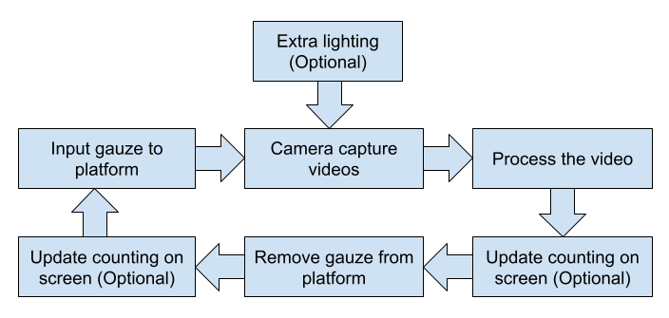

Figure 3: Operation flow chart

The system operates rather simple, as shows in figure 3 it starts by placing gauzes on the platform and the camera above will keep capture the video. As soon as a gauze enters the field of view, the AI system recognizes it and updates the count on the screen. The AI system is trained to differentiate gauzes from other objects and provides real-time updates on the number of gauzes counted on a screen.

### 3.1.2 Design Concepts

After conducting the function analysis of the gauze counting system, several conceptual designs were proposed.

Conceptual Design 1: Automated Conveyor System (Figure 4)

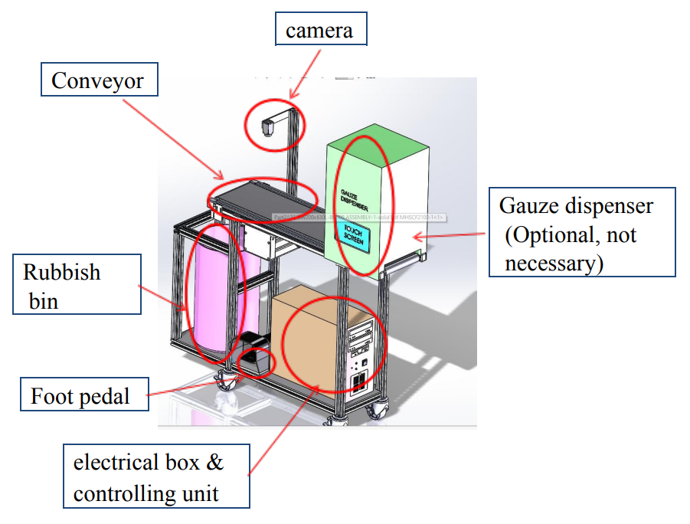

Figure 4: Automated Conveyor Concept

The automated conveyor system is designed to minimize manual labour in the gauze counting process. The system consists of several components, including a structure frame with 4 wheels, conveyor, a camera, a foot pedal, a gauze dispenser (optional), a controlling unit and a rubbish bin. The function of each component are as follow:

* Conveyor: The conveyor serves as the transport mechanism for the gauze from the input end to the output end.
* Camera: The camera is mounted above the conveyor to capture images of the gauze passing by. The camera uses object recognition algorithms to identify the gauze and count it.
* Foot Pedal: The foot pedal is used to activate the conveyor and start the gauze counting process. The foot pedal allows the nurses to keep their hands free during the counting process.
* Gauze Dispenser (Optional): The gauze dispenser is an optional component that can be added to the system to automate the loading of new gauze. The dispenser is triggered by the foot pedal and dispenses a new gauze onto the conveyor.
* Rubbish Bin: The rubbish bin is located at the output end of the conveyor and collects the used gauze after they have been counted.
* Control unit: The control unit is to supply the power for whole system as well as to make the necessary computational process of the counting.

Conceptual Design 2: Tray-based Conveyor System (Figure 5)

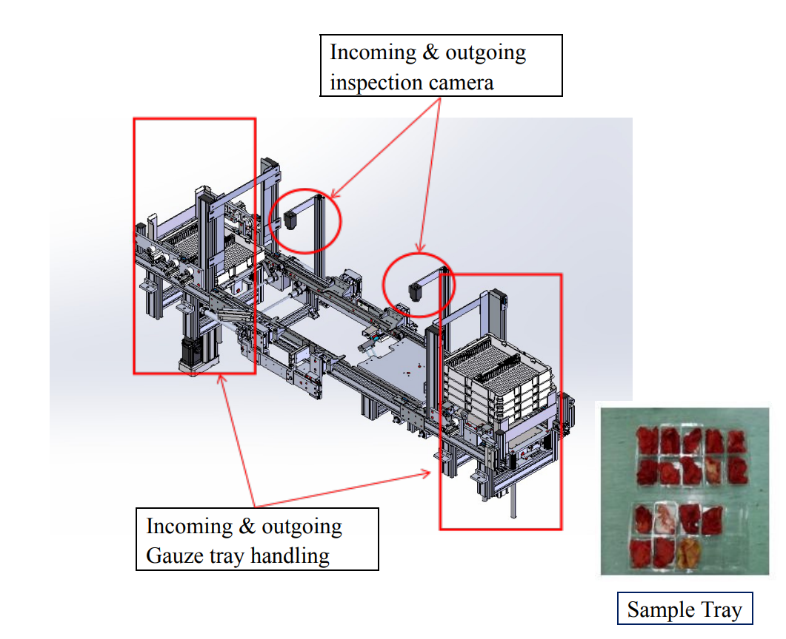

Figure 5: Tray-based Conveyor Concept

The tray-based conveyor system is similar to concept 1. But it designed to count gauze that is loaded into a tray with multiple pockets. The tray is then placed onto a conveyor, which transports the gauze under the camera for counting.

Both of the automation concepts were ultimately rejected due to concerns around the complexity of the design and the space required. One major concern was the difficulty of sterilizing the conveyor systems and the various other components involved, which could compromise the safety and effectiveness of the gauze counting system. Additionally, the proposed designs would take up significant amounts of space in the already crowded operating room environment, potentially causing logistical and safety issues for medical staff. As a result, alternative designs were explored that focused on simplicity, ease of use, and minimal space requirements.

Conceptual Design 3: Desk lamp (Figure 6)

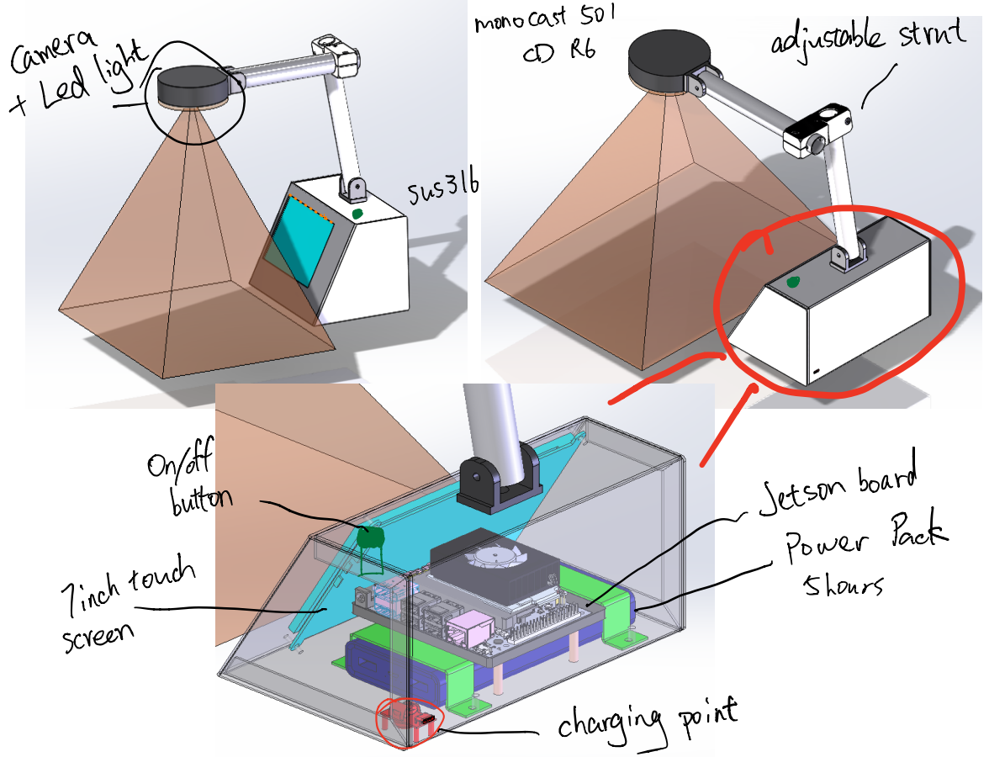

Figure 6: Desk Lamp Concept

The third concept involved a desk lamp-style design, with the camera positioned at the top with LED light and the processor contained in a box will be placed on the table. This allowed for greater mobility as the design is compact and a battery is also built in. The camera position could be adjusted with the arm, and a touch screen was included for ease of use. However, this concept was ultimately rejected due to the base box not being sterilizable, posing a potential risk to patient safety.

Conceptual Design 4: Drip stand concept (Figure 7)

In this case, the author then moved on to the fourth concept, which aimed to address the sterilization concerns of the previous designs. This concept involved mounting the system on a drip stand, with the camera, processor, and lighting contained in a box above the tray. The tray was connected to the main frame, allowing the nurse to place a drape on it to serve as a sterilizing cover. This design allowed for greater flexibility and ease of use while also addressing the sterilization concerns.

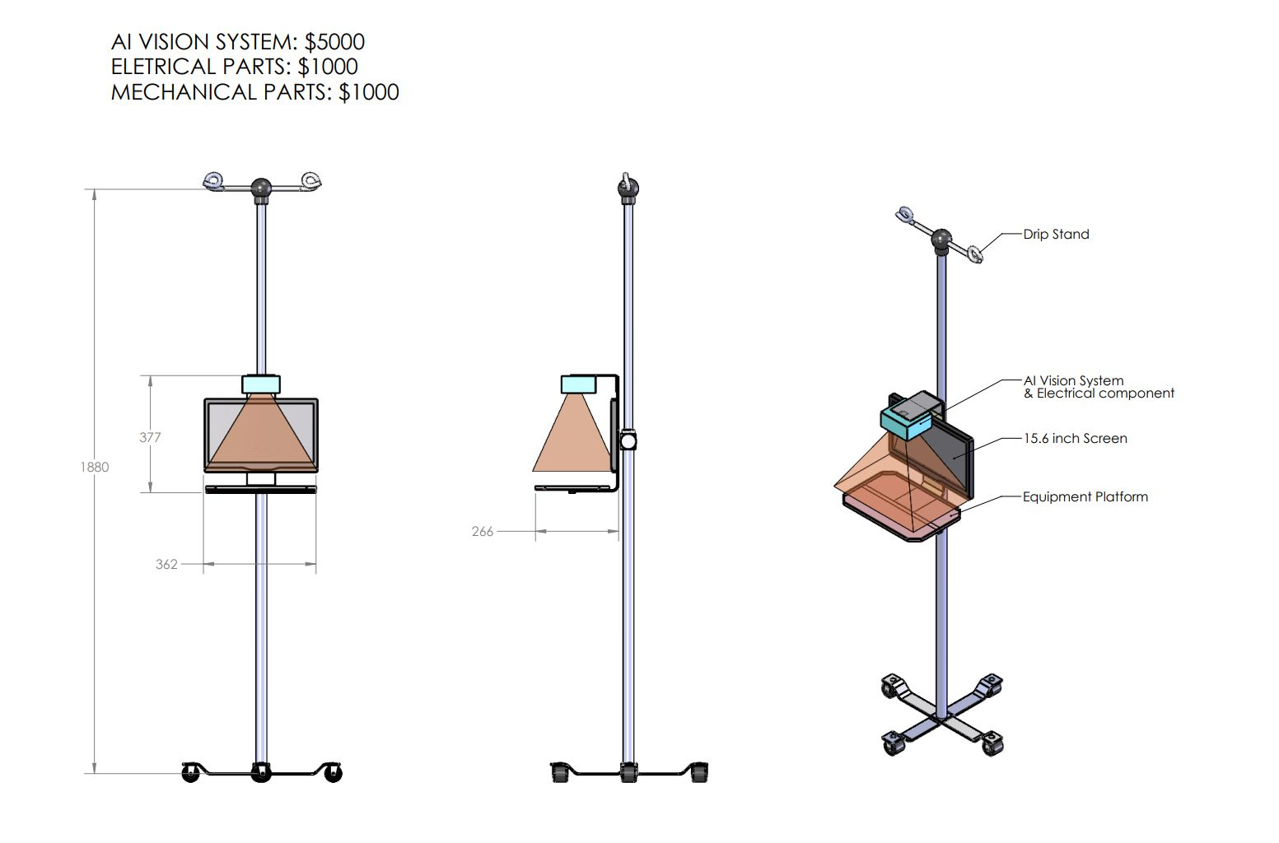

Figure 7: Drip Stand Concept

While the third concept offered greater mobility, the lack of sterilization capabilities made it unsuitable for use in a medical setting. The fourth concept, however, offered a more practical and streamlined solution that could be easily sterilized and adapted to fit within the existing operating room setup. Additionally, the use of a drip stand made it easily transportable, allowing it to be used in multiple operating rooms throughout a hospital.

In conclusion, while the team explored various conceptual designs for the gauze counting system, the practicality and sterilization capabilities of the fourth design ultimately made it the most suitable option for use in a medical setting. By addressing the concerns raised by previous designs and incorporating a sterilizable tray and U-shaped stand, the team was able to develop a streamlined and practical solution that met the needs of medical professionals and patients alike.

## 3.2 Embodiment Design

Embodiment design refers to the process of converting a conceptual design into a physical prototype or model. It involves choosing the materials, components, and manufacturing processes that will be used to create the final product. In the case of the gauze counting system, the embodiment design phase would involve choosing the specific materials and components that will be used to create the system, as well as determining the manufacturing processes that will be used.

### 3.2.1 Design 1 with edge device

The fourth concept, which involved mounting the system on a drip stand, was chosen as the best design option due to its portability and ease of sterilization. An embodiment design had been made shows in figure 8. For the tray and frame, SUS304 sheet metal was chosen as the primary material. This material is durable, corrosion-resistant, and easy to clean, making it ideal for medical applications. The use of sheet metal also allows for customization and precision in manufacturing.

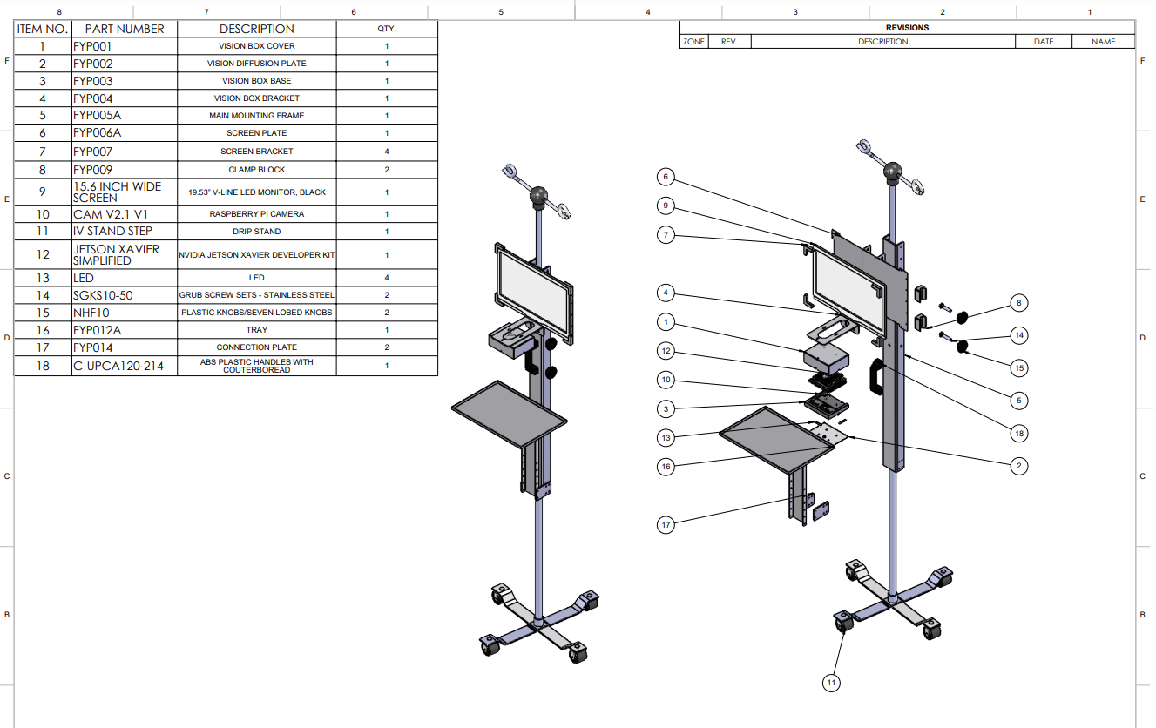

Figure 8: Drip Stand Concept Final Design

To house the Jetson Xavier NX development kit, a monocast mc501cd r6 machined base was selected. This ESD base provides a stable platform for the processor and is specifically designed for use with electronic devices. The cover for the processor is also made of sheet metal, providing protection for the processor while allowing for easy access when necessary.

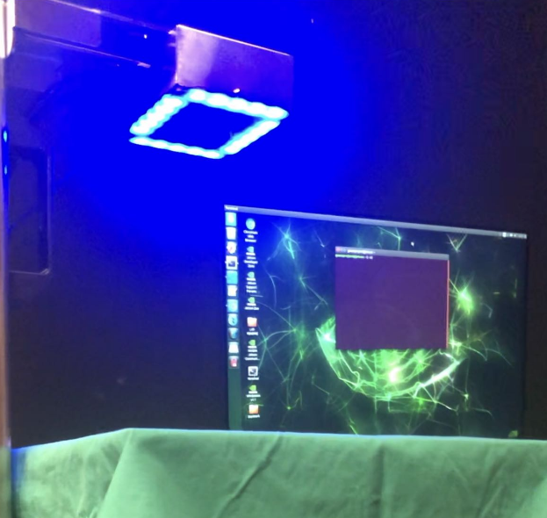

Figure 9: Led Light On The Real Product

An LED light shows in figure 9 was added under the processor to illuminate the tray and provide better visibility during gauze counting. A mild white acrylic was used to diffuse the light, which also helps to reduce glare and eyestrain for users.

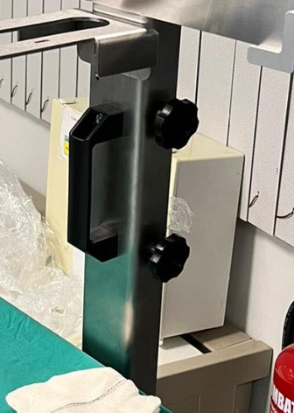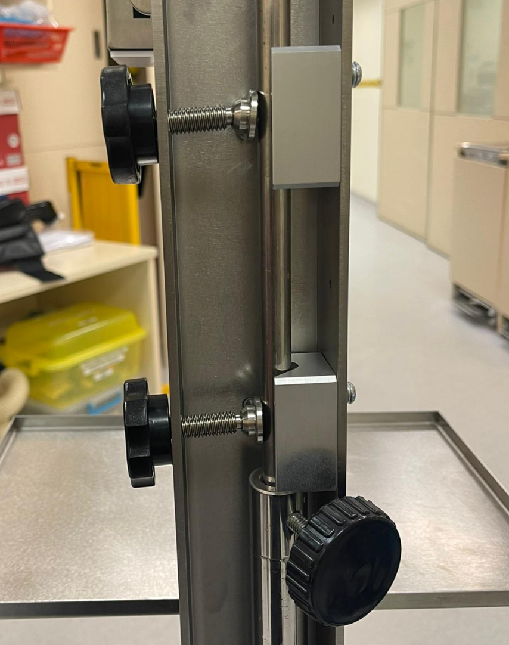

(A) (B)

Figure 10: (A) Handle, (B) Gripping Mechanism

Standard parts from Misumi were selected to mount the system on a drip stand. These include the handle and clamp shows in figure 10 & 11, which provides a secure and stable mount for the system. The main frame of the system contains several holes, allowing for adjustments to be made to the height of each component. This ensures that the system can be customized to meet the specific needs of different users and applications.

Eventually, a screen was added above the camera to display the gauze count in real-time. This feature makes it easy for users to keep track of the gauze count and ensures that the system is functioning correctly.

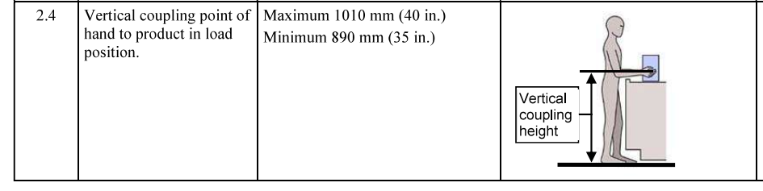

Figure 11: Semi S8-0218 Section 2.4

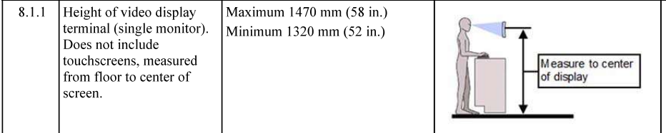

Figure 12: Semi S8-0218 Section 8.1.1

The height of the tray was designed to follow SEMI S8-0218 standards, which are based on ergonomics principles. In addition, the design of the tray, camera and the screen position are adjustable by assemble them to different mounting holes. This ensures that the system is comfortable for users to operate and helps to prevent injuries caused by repetitive motion or awkward postures.

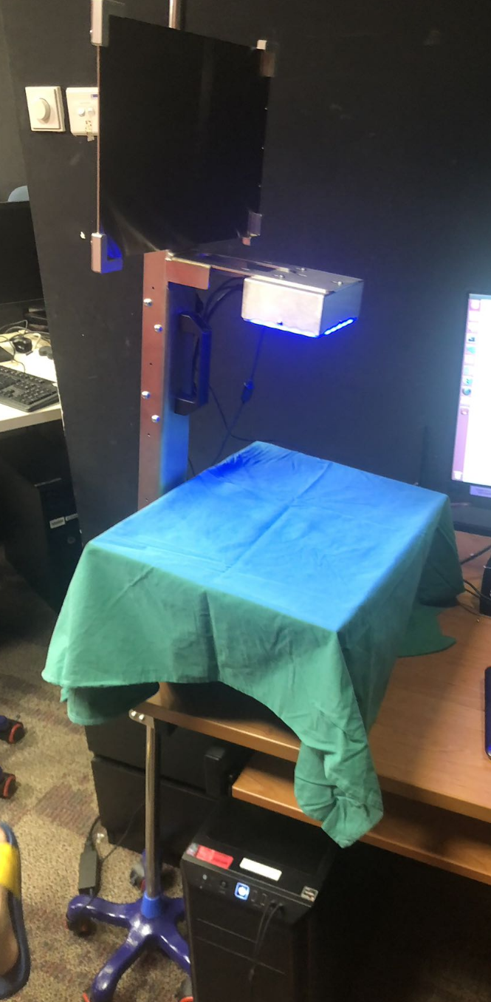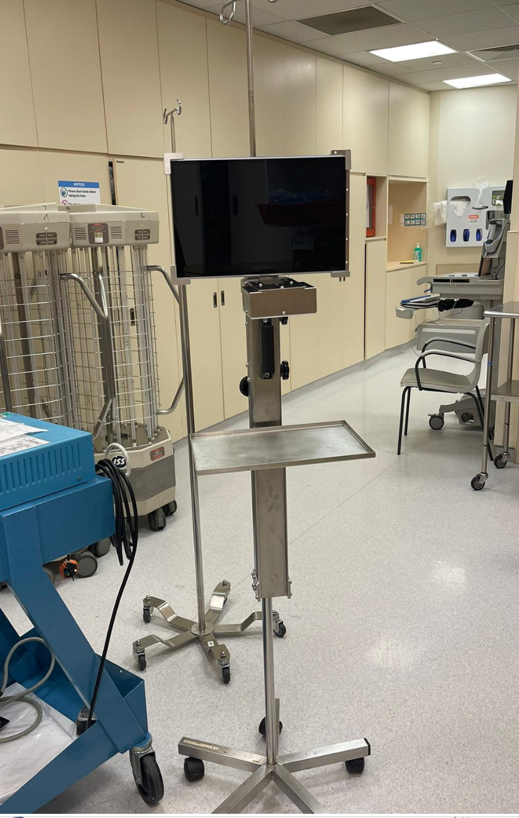

(A) (B)

Figure 13: (A) Actual Prototype, (B) Prototype in Hospital

Overall, the embodiment design for the gauze counting system is a robust and functional solution that meets the requirements of the medical industry. By using high-quality materials and standard parts, the system can be easily manufactured, assembled, and maintained. The design also allows for customization and flexibility, ensuring that the system can be adapted to meet the needs of different applications and users.

### 3.2.2 Design 2 with PC

After thorough testing, meetings, and a visit to the simulation operation theatre, it was decided that the previous design using a drip stand was not practical. The first reason was that the Jetson board's processing speed was not satisfactory when running a larger size of YOLOv5. This meant a more powerful processor was needed, which would be larger, for example a PC. The second reason was advice from Dr. Luke, who stated that the system with two drip stands still occupied too much space in the operation theatre. To address these concerns, a new design was developed that combined two trays on a single frame, each with its own camera above the tray. 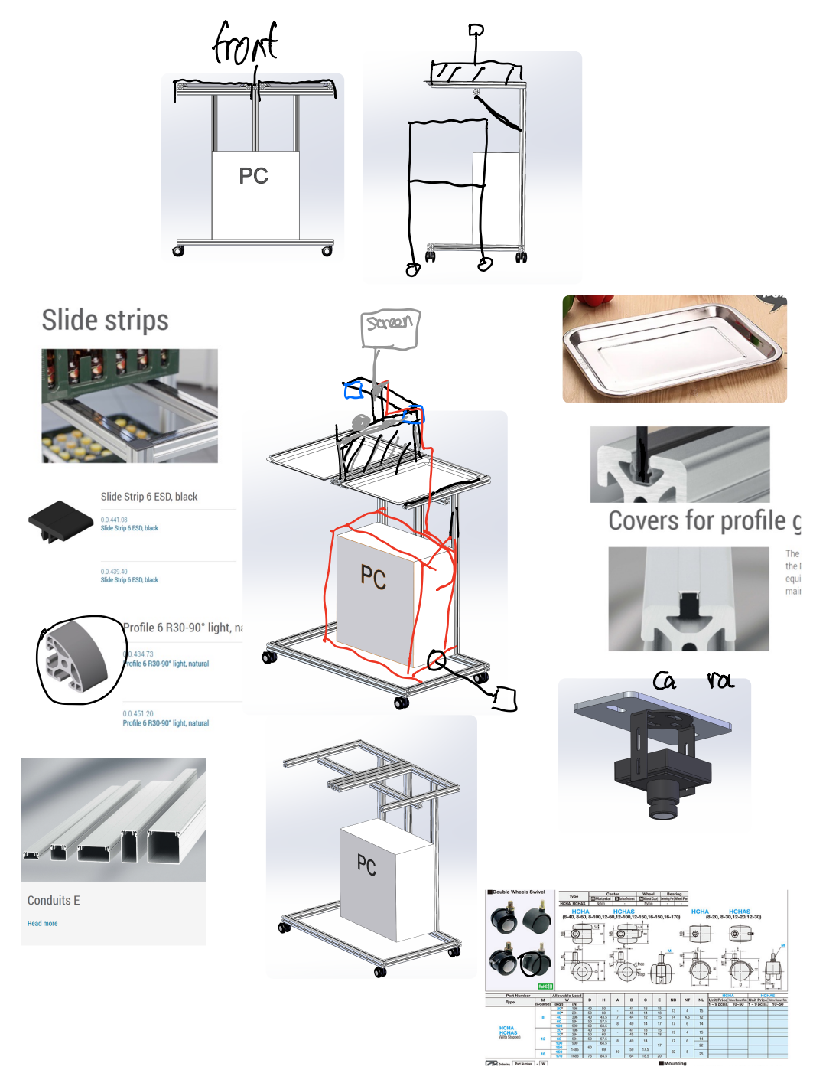

Figure 14: Components In PC Version Design

The frame is made of an aluminium profile connected with universal joints and angle brackets, making it adjustable for different tray sizes. The design is in a C shape, allowing it to be placed over other standard trays or tables in the operation theatre to save space. The trays will use standard trays instead of the sheet metal bent one in the previous design, making them more easily replaceable. Additionally, the trays can slide in and out on the structural frame with the sliding strip to protect the frame and make it easier to slide.

One major change to the design was the removal of the screen from the system. After consulting with Dr. Luke, it was determined that no one would have time to look at the screen during an operation. Therefore, the screen can be put aside and does not need to be on the main system, saving additional space.

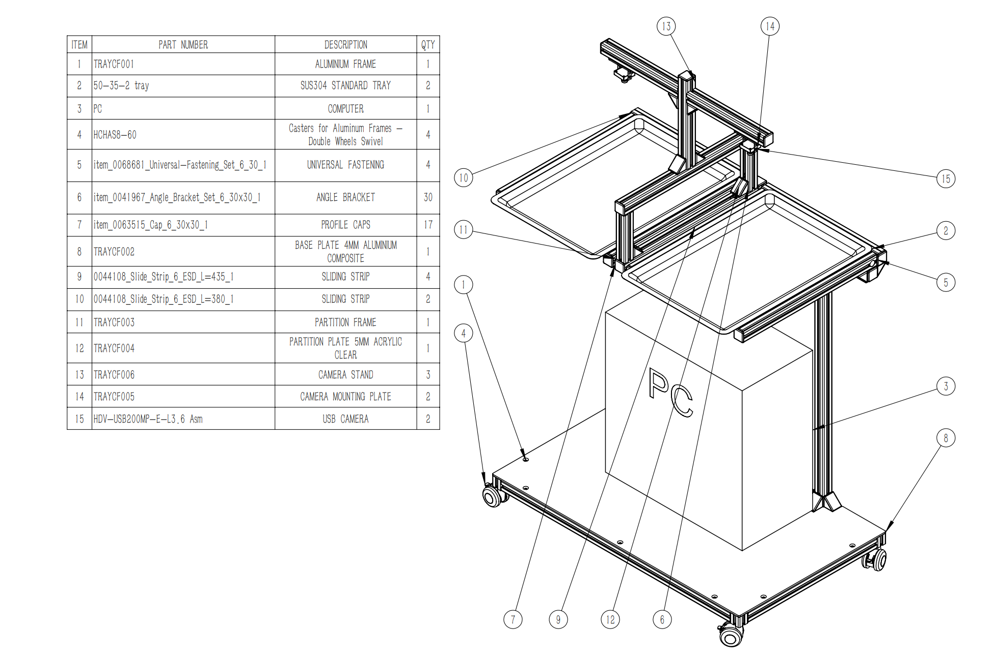

Figure 15: PC Version Final Design

Overall, this new design is more efficient and practical than the previous ones, as it allows for greater flexibility with different tray sizes, is more easily replaceable, and takes up less space in the operation theatre. With the previous concerns regarding the processing speed and space consumption addressed, the system is ready to be further developed and tested.

# Chapter 4 IGauze Software Design

The software design of the system is an essential part of its functionality, and it is important to choose the appropriate software tools to ensure the system operates efficiently. In this case, we will be using Python as the primary programming language for the system. In this chapter, the development processes of the software part will be discussed.

## 4.1 Set-Up of environment

Before embarking on the software design for the AI system, it is important to set up the coding environment. The project was proceeded with two devices, a desktop with a GTX 1080Ti GPU for training purposes, and a laptop for demonstrating the system. The environment setup is essential for both devices.

First step is to install Anaconda, which is a popular open-source distribution of Python for scientific computing, and Jupyter Notebook, which is an open-source web application that allows us to create and share documents that contain live code, equations, visualizations, and narrative text. [25] It can be downloaded at its official website.

The purpose of using Anaconda is to set up a virtual environment, which allows us to work with different versions of Python and different packages without interfering with other projects. With a virtual environment, we can create an isolated space where we can install and manage the required packages without affecting the global environment.

PyCharm also needs to be installed, which is an Integrated Development Environment (IDE) that provides a powerful code editor and debugging tools for Python. Most of the YOLOv5 source code is in Python, so using PyCharm helps us navigate the code and understand the logic behind it as well as train the model.

Following by installing CUDA and cuDNN, which are essential for using PyTorch with GPUs. CUDA is a parallel computing platform and application programming interface (API) developed by NVIDIA for GPUs, while cuDNN is a GPU-accelerated library for deep neural networks. Together, these tools provide significant speedups for training and running deep learning models on GPUs. [26]

Before installing CUDA, it's important to know which version of CUDA is compatible with your graphics card. To find out, follow these steps:

1. Press the "Win + R" keys on your keyboard to open the Run dialog box.
2. Type "cmd" and press Enter to open the Command Prompt.
3. Type "nvidia-smi" and press Enter to display information about your graphics card.
4. Look for the "CUDA Version" in the upper right corner of the table and take note of it. (Figure 18)

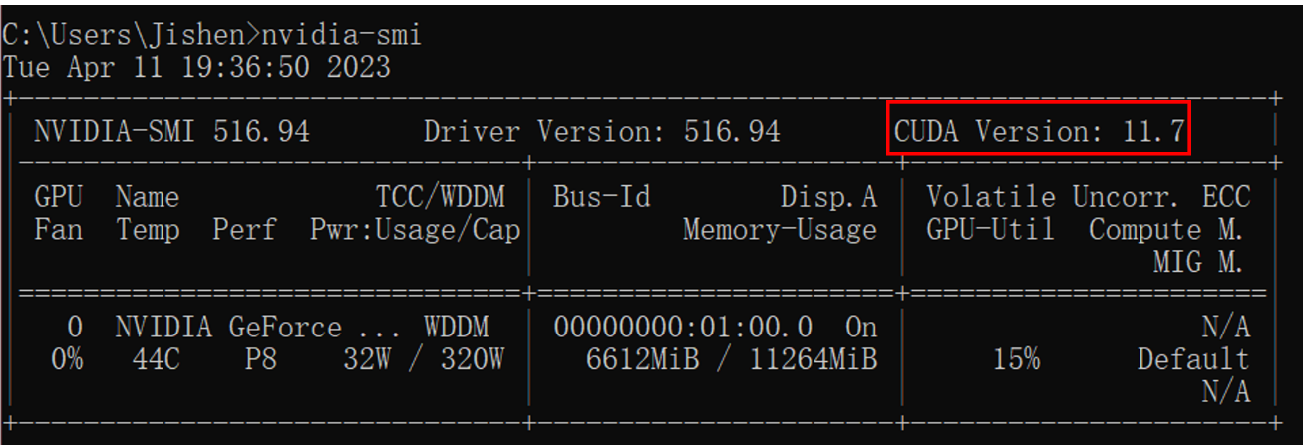

Figure 16: CUDA Version Checking

In this project CUDA version 11.7 is compatible with the GPU, next will be the steps to install CUDA:

1. Download the appropriate version of CUDA from the official NVIDIA website.
2. Run the installer and follow the on-screen instructions to install CUDA.
3. 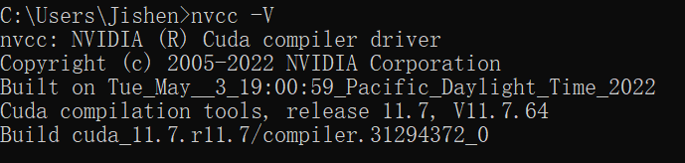After installation, open the Command Prompt again and type "nvcc -V" to verify that CUDA was installed successfully. (Figure 19)

Figure 17: CUDA Installation Status

After installing these external tools, will move on to the virtual environment installation. First created a virtual Python environment using Anaconda with following steps:

1. Open the Command Prompt as previous steps
2. type "conda create -n env_name python=X.X", where "env_name" is the name of the virtual environment you want to create and "X.X" is the version of Python you want to use (recommended 3.7 or higher).
3. Activate the virtual environment by typing "activate env_name" and press Enter.

To continue then will install PyTorch in the virtual environment. It is a popular deep learning framework for Python provides easy-to-use tools and libraries for building and training deep neural networks, making it an ideal choice for our project. Download the appropriate version of PyTorch for your CUDA version from the PyTorch website. Choose and copy the pip installation command under the "Command" column for your corresponding CUDA version. And then paste it into the command prompt within your virtual environment. Press Enter to download and install PyTorch.

After installation, check the PyTorch version by typing "python" in the command prompt to enter the Python terminal. Then, type "import torch" and "torch.__version__". If the version is displayed, it means that PyTorch is installed successfully. (Figure 20)

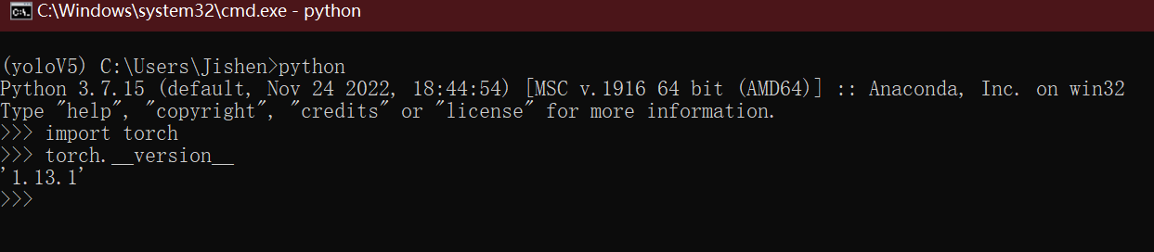

Figure 18: PyTorch Version Checking

In summary, setting up the coding environment involved installing Anaconda, Jupyter Notebook, PyCharm, CUDA, and cuDNN. We also created a virtual Python environment and installed PyTorch for deep learning. With these tools in place, we can move forward.

## Data preparation

### Raw images collection

Data preparation is a crucial step in developing any computer vision model, and in the case of gauze detection, it is particularly important due to the limited availability of annotated images online. Therefore, the author had to create a dataset for training and testing current model.

To create the dataset, images are collected from various sources. Firstly, the author looked for images from past studies conducted by NTU FYP students. These 1,000 images were particularly useful because they were already annotated, which saved a lot of time and effort in the annotation process.

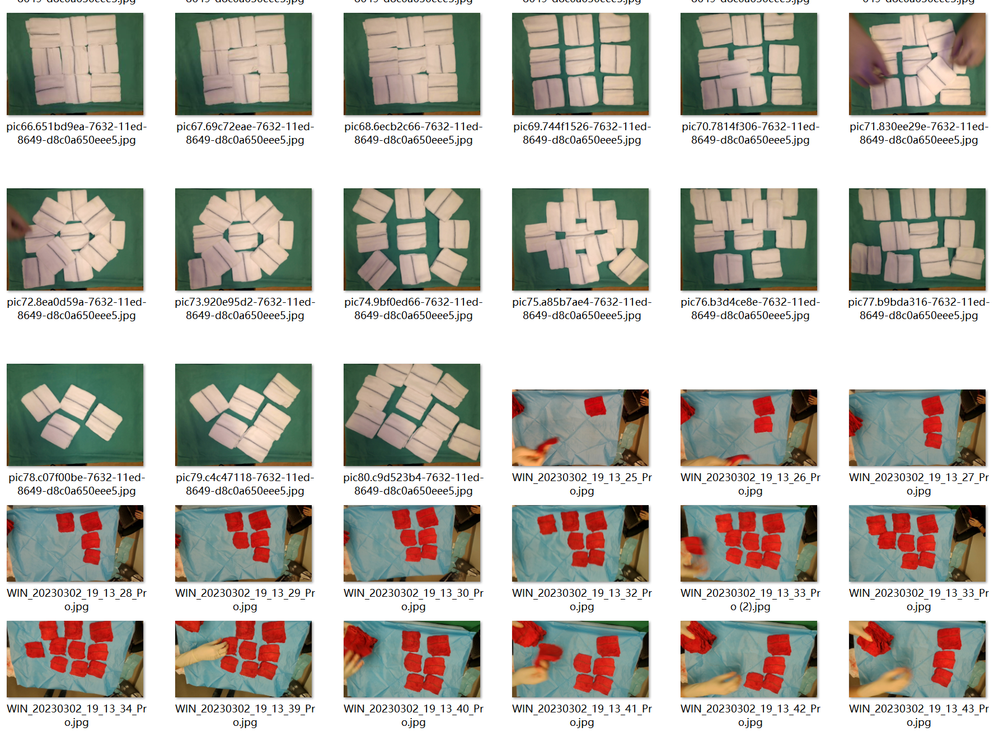

Figure 19: Raw Data Samples

New photos of clean gauzes were taken by the author to increase the variety of dataset. The new captured images of gauzes were from different angles, with varying lighting conditions, and spaced out differently to ensure that the model could generalize well to different settings. To further increase the variety of the dataset, Mr. Aaron from SGH also assisted on the data collection process for those real used gauzes.

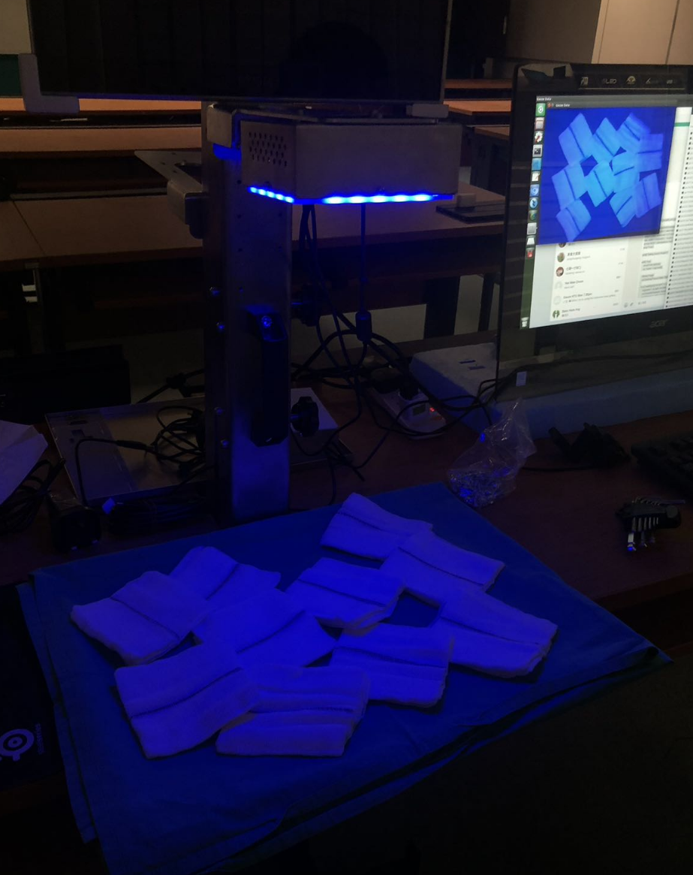

Figure 20: Sample Set Up For Data Collection

Finally, a dataset with 2,182 gauze images is collected. These images are then split into three set 75% for training, 15% for validation, and another 10% for test.

### 4.2.2 Image Pre-processing and Augmentation

Roboflow is used to label, pre-process and augment the raw data in this project. It is a popular online platform that can be used to label images for machine learning projects. It offers a range of features to help streamline the image annotation process, making it faster and easier to label large datasets. Compared to the previous tools used by the past studies, such as CVAT platform and COCO annotator, Roboflow offers more convenience and flexibility. One of the major benefits is that it can generate various formats that will be useful for the future development of the project. In addition, Roboflow has built-in pre-processing and augmentation tools, which can save a lot of time and effort for the users.

After labelling the images all in 1 class or 3 classes, pre-processing was performed on them. The first step was to auto orient and resize the images to 640x480, although the recommended size for YOLOv5 is 640x640, the image ratio has to be consistence. This size also helps to make the training process faster. The images were then converted to grayscale. This step helps the model to recognize clean white gauze better and avoid detecting other objects as gauze, which was an issue in previous studies. However, coloured images are also tested in this project.

To generate more training data, augmentations were applied on the images. Three augmentation rules used: rotation between -21 and +21 degrees, noise up to 5% of pixels, and cut-out three boxes with 10% size each. These augmentations helped to generate a total of 5,548 images, which is a significant increase compared to the previous study. This method of generating augmented images after labelling helped to prepare the dataset much faster. In table 2 shows the different model evaluated in this project and their associated pre-processing and augmentation techniques.

Table 2: Summary of Model Trained

|  |  |  |  |
| --- | --- | --- | --- |
| **Model** | **Labelled Classes** | **Preprocessing** | **Augmentation** |
| GAUZEv5best | Gauze | Auto-Orient, Stretch, Grayscale | Rotation, Noise, Cutout |
| GAUZEBW | Gauze  Stained Gauze  Red Gauze | Auto-Orient, Stretch, Grayscale | Rotation, Noise, Cutout |
| GAUZECOLOR | Gauze  Stained Gauze  Red Gauze | Auto-Orient, Stretch | Rotation, Noise, Cutout |

## 4.3 AI Model Training

Table 3: YOLOv5 Weight Specification

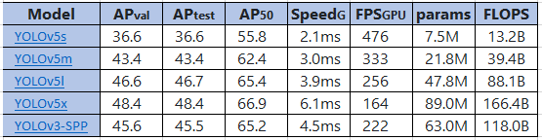

After comparing the pretrained checkpoints table in the YOLOv5 repository (table 3) with the available GPU resources of a 1080TI, it was decided to choose YOLOv5l for this project. The PC configuration used for model training includes GTX 1080TI GPU, a I7-8700K CPU, and 32GB 3200MHZ RAM. The training process for 300 epoch takes up to 35 hours with yolov5l model.

The following steps was used to train the model [27]:

1. First, export YOLOv5 PyTorch format data from Roboflow. This can be done by selecting "YOLOv5 PyTorch" as the export format and downloading the resulting file.
2. Once the data is exported, create a YAML file in the data folder. This file should contain information about the dataset, such as the location of the images and labels. You can use an existing YAML file as a template and modify it as needed.
3. Open the YAML file with PyCharm and edit the code inside. You will need to update the paths to the training and validation sets, as well as other settings such as batch size and number of classes.
4. Set up YOLOv5: Download the YOLOv5 code from the official repository and install the required dependencies. You can do this by following the instructions in the README file.
5. Open the Command Prompt and navigate to the YOLOv5 folder.
6. Type the command "python train.py --weights yolov5l.pt --data name.yaml --epochs 300 --img 640" to start training the YOLOv5 model. Replace "name.yaml" with the name of the YAML file you created earlier. You can also adjust the number of epochs and image size as needed.
7. You can monitor the training progress by viewing the output in the Command Prompt. The model will automatically save checkpoints during training, which can be used for inference or continued training.

## 4.4 Process Flow

The software developed for gauze counting has a well-defined process flow that enables it to provide accurate results in real-time. The system is designed to start automatically when the cameras are turned on, and it captures the video feed from two different cameras. The AI model is then deployed to process the video stream in real-time, ensuring that the gauze counting process is efficient and accurate.

As soon as the nurse puts a gauze on either the input or output tray, the system immediately detects it. It then monitors the gauze's movement and updates the count based on the time it stays under the view. If the gauze remains detected under the view for more than seven frames, the system updates the count in either the input or output tray, depending on where the gauze is placed. This process ensures that the count is accurate and up-to-date.

In addition to the input and output trays, the system also calculates the in-play number, which is the total number of gauzes currently being used. The calculation is based on the total number of gauzes inputted minus the total number of gauzes outputted minus the number of gauzes on the tray.

Furthermore, the system is designed to detect human presence, which is crucial for ensuring accurate gauze counting. When the system detects human presence, the counting process is temporarily halted to prevent any interference. Once the human leaves, the counting resumes from where it left off. This feature ensures that the gauze counting process is not disrupted and provides accurate results consistently. A simplified process flow chart is shown in Figure 23.

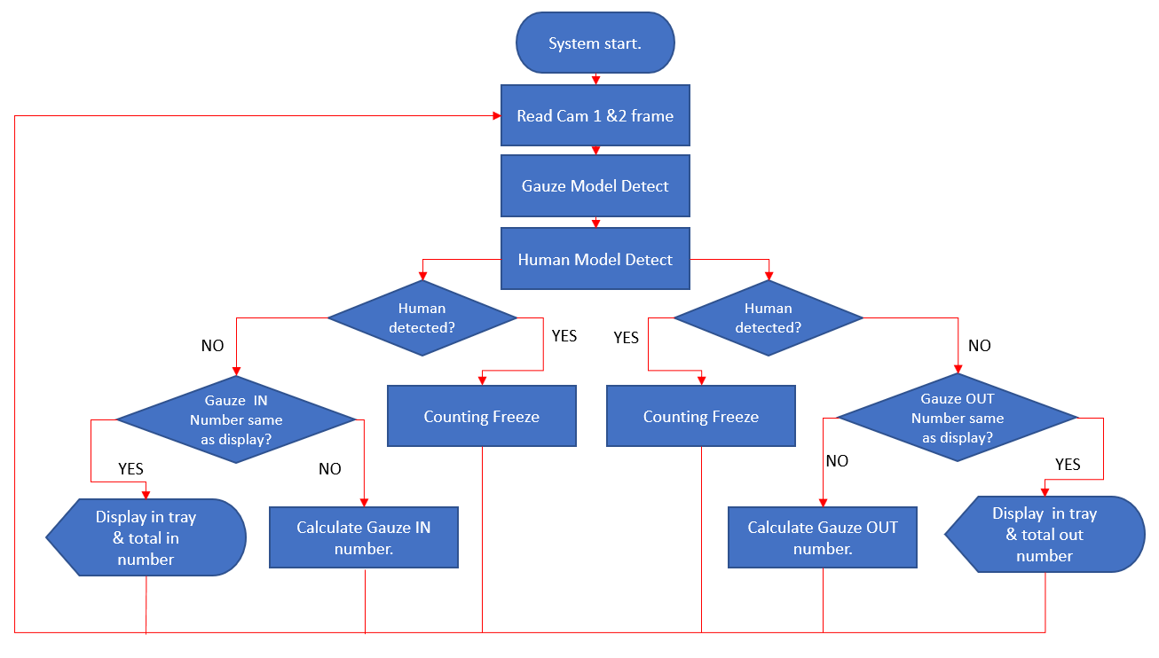

Figure 21: Software Process Flow

Overall, the gauze counting software's process flow is well-designed to ensure accuracy and efficiency in real-time. The integration of AI models for gauze counting and human detection, coupled with the design of the input/output trays and the in-play calculation feature, all work together to create a seamless and effective system for gauze counting in surgical procedures.

## 4.5 UI design

When it comes to designing the user interface (UI) for any software project, it's important to keep the end-users in mind. In the case of this project, the end-users would be the medical professionals who will be using the tool to detect the presence of gauze in surgical images.

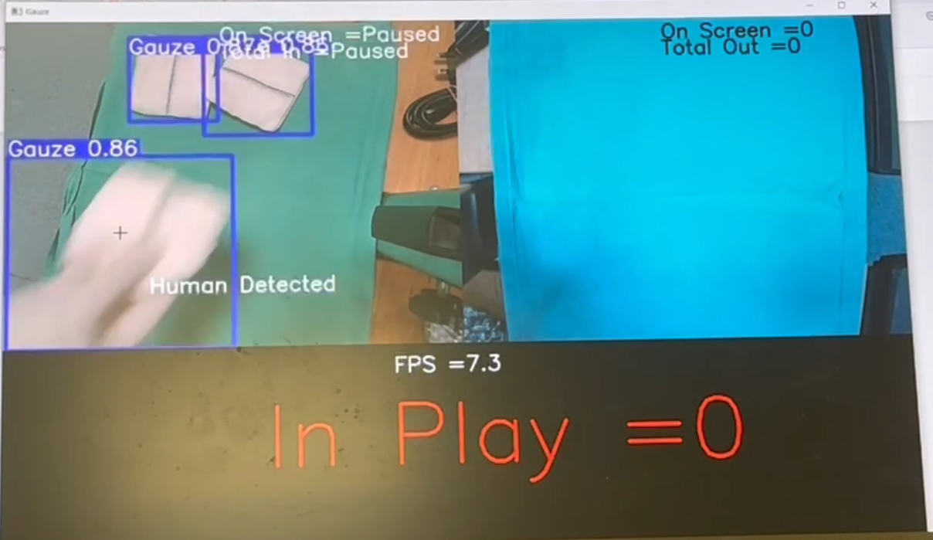To begin with, it would be best to keep the UI simple and intuitive. The main purpose of the UI is to display the surgical images and highlight any areas where gauze is detected. As well as displaying the counting numbers.

Figure 22: UI Design

# Chapter 5 Result and Discussion

## 5.1 Testing method

Two types of tests were performed to evaluate the performance of the models developed in this project.

The first type of test is to run the models in PC on the testing dataset which contained images of real blooded gauzes during the operations and clean gauzes. Due to safety concerns, the use of real blooded gauze for testing in lab environment was not feasible, therefore this method was used and a sample result is reveals in figure 25.

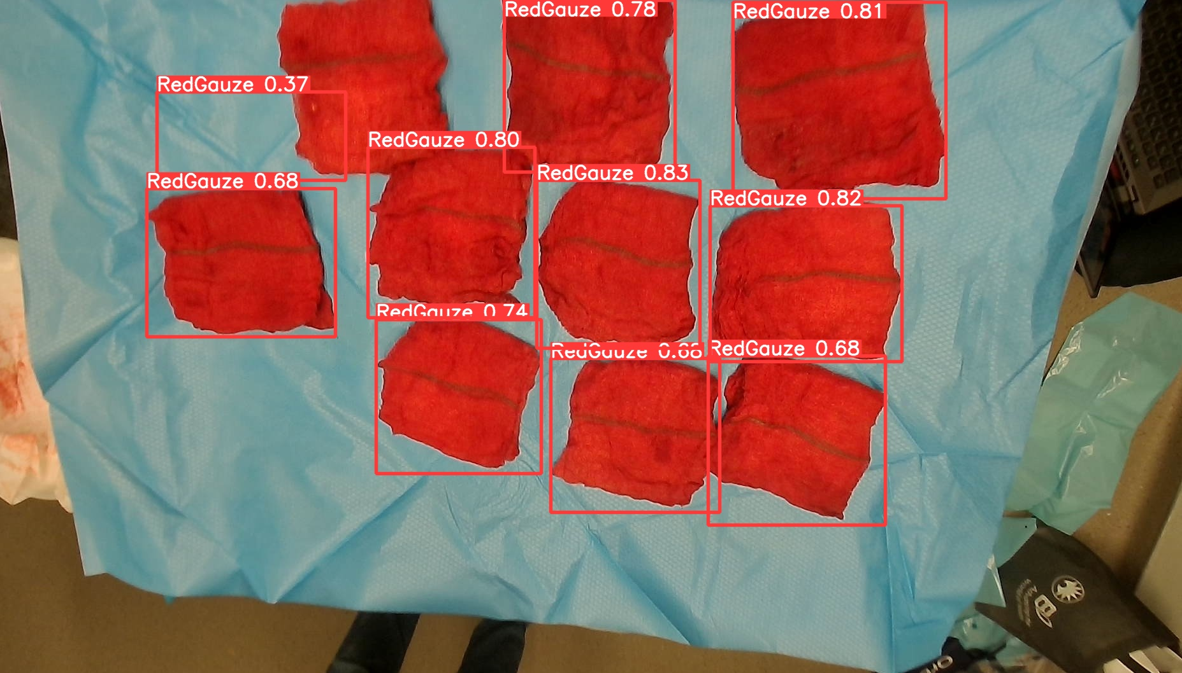

Figure 23: Testing in PC

The second type of test was conducted in a real-world environment both in the lab and in a simulated operation theatre. Set up of hardware frame using the drip stand version to hold the camera and connect it to a laptop. We placed the hardware frame in the lab and tested the models' performance in a real-world environment by place clean gauze and fake red gauze on the tray with green drape covered as background. And the placing of the gauze is For the GauzeV5best models, was also tested it in a simulated operation theatre, where the camera was handheld to capture the view of gauze, and the nurses placed blooded gauze in the field of view.

During the testing process, placement of gauze was controlled, the gauze was placed less than 50% overlapping and put in and take out one by one. It is better to space out the gauze on the tray to get a clear view of each of them in the camera frame. Moreover, the black line on the gauze needs to be visible to the camera to ensure that the AI model can detect it accurately. The black line helps to differentiate the gauze from other objects in the camera frame. The lighting is also controlled during the testing, and it is typically done in NTU CAE LAB with the lights on at night without the involvement of sunlight to simulate the environment of an operation theatre.

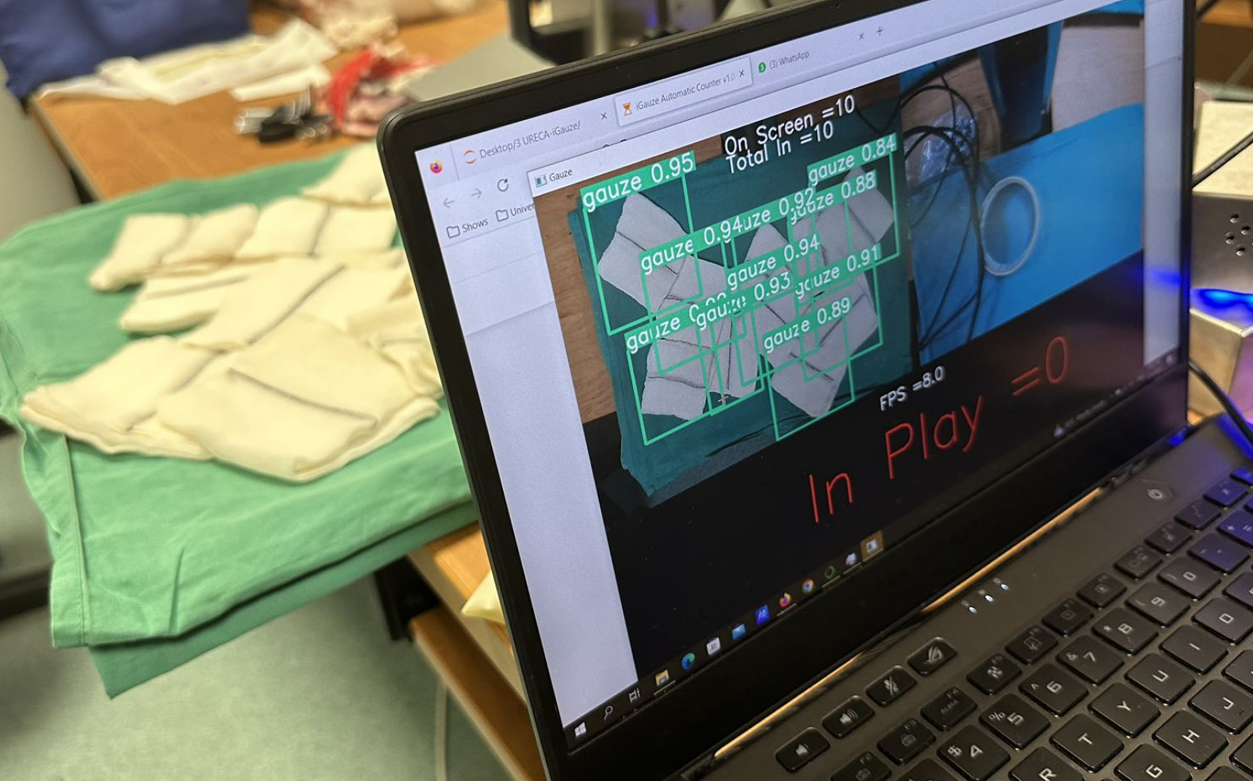

Figure 24: Real-World Testing

## 5.2 Evaluation of AI model

Table 4: Model Result

|  |  |  |  |  |
| --- | --- | --- | --- | --- |
| **Model** | **Precision** | **Recall** | **F1 Score** | **mAP@0.5** |
| GauzeV5 | 98.67 | 99.28 | 98.97 | 99.42 |
| GAUZEBW | 95.48 | 96.01 | 95.74 | 96.83 |
| GAUZECOLOR | 94.49 | 95.67 | 95.58 | 97.05 |

The results reveal in table 4 that the gauzeV5 model performs the best in detecting gauze, with high precision, recall, f1, and mAP@0.5 values. However, it fails to detect blooded gauze in the real-world testing, which is a critical limitation for its practical application.

On the other hand, both GAUZEBW and GAUZECOLOR models perform better in detecting blooded gauze, maybe because of they are labelled by three classes. However, they sacrifice some confidence levels in detecting clean gauze. The confidence level usually falls around 64% to 87% is relatively low compares to GauzeV5 model which is 97%

The performance difference between GAUZEBW and GAUZECOLOR might be attributed to the use of colour images in training the latter model. Colour images contain more information than grayscale images, which might help the model to learn more complex patterns and features. However, it increases the computational complexity of the model and requires more computing resources. As a result, a lower precision has occurred. This can make it harder for the model to differentiate between similar objects or textures, such as tissue paper and gauze.

It is worth noting that the testing conditions were controlled, and the placement of gauze was less than 50% overlapping, and the black line on the gauze was shown to the camera. In real-world settings, the conditions might not be as controlled, which could affect the performance of the models.

In conclusion, while GauzeV5 performs well in detecting clean gauze, it fails to detect blooded gauze in the real-world testing. GAUZEBW and GAUZECOLOR models perform better in detecting blooded gauze, but at the cost of sacrificing some confidence levels in detecting clean gauze. The use of colour images might improve the performance of detecting blooded gauze, but also increases the computational complexity which decrease the precision. The choice of model depends on the specific application condition and the trade-off between detection accuracy and computational resources.

## 5.3 Current limitation

The current approach of using object detection to count the gauzes has some limitations.

Firstly, the accuracy of object detection models depends heavily on the quality and quantity of the training data. If the model is not trained on a diverse and representative dataset, it may not be able to detect all instances of the target object accurately. Therefore, the current model still has chance to miscount another object as gauze.

Secondly, the detection performance of the model may be affected by factors such as lighting conditions, occlusion, and image quality. For example, if the gauze is partially covered by other objects in the image or if the image is blurry, the model may not be able to detect the gauze accurately. In this case, a regular maintenance may be needed.

Thirdly, object detection models are generally slower than classification models because they need to perform object localization in addition to object recognition. This may limit the real-time performance of the system. Although current 10 FPS is functional to carry out the operation, the video stream to be better at 60 FPS.

Finally, the current approach assumes that each gauze can be accurately detected as a single object and the placing of gauzes were controlled, which may not always be the case. For example, if two or more gauzes are fully overlapped or intertwined, it may be difficult for the model to distinguish them as separate objects.

# Chapter 6 Conclusion

## 6.1 Contribution

The following contribution has been made:

1. Designed and developed two hardware frames to hold the camera and processor more securely and improve the overall appearance of the system.
2. Created a more presentable product, which could potentially attract commercial interest.
3. Develop automatic counting software and integrated human detect function which eliminated the need for human input and reduced the possibility of human error.
4. Collected more than 1000 raw data points to improve the accuracy of the models.
5. Trained new models using the collected data, which resulted in improved precision and recall values.
6. Coordinated and collaborated with suppliers, other students, and hospital staff to ensure the project's success.
7. Visited the hospital to collect data and conduct meetings, which facilitated the smooth implementation of the project.

## 6.2 Future Work

While the current approach to counting surgical gauzes has shown promising results, there are several areas of future work that can be explored to further improve the accuracy and usability of the system.

One area of future work is to expand the dataset to include a wider range of used gauze and overlapped gauze, as well as variations in lighting and background. This can be achieved through continued data collection efforts and the use of generative adversarial networks (GANs) to create synthetic images that can supplement the existing dataset. By training the model on a more diverse range of images, it may be able to better handle variations in gauze appearance and improve its accuracy.

Another area of future work is to explore alternative object detection models or other AI that may be better suited to the task of counting surgical gauzes. While YOLOv5 has shown promising results, other models such as YOLOv8, GPT4 and segment-anything by meta may also be effective and should be evaluated. Additionally, ensemble models that combine multiple object detection models may provide even greater accuracy and robustness.

In terms of the hardware, future work could focus on developing a more cost-efficient frame that the manufacturing process can comply with standard ISO13485. A more powerful GPU would be good to speed up the training process.

Additionally, since the project received grant from SGH clinical trials will be conducted to evaluate the performance of the developed system in real-world surgical settings. The trials will involve a larger sample size of gauzes. The data can be collected and used to further refine the developed models and improve their accuracy in detecting gauze in surgical settings.

Finally, future work could focus on expanding the scope of the system beyond surgical gauze counting to include other surgical tools and equipment. By developing a more comprehensive system for surgical instrument detection and counting, hospitals and medical centres can improve their inventory management and ensure that they always have the necessary equipment on hand for any given procedure as well as reduce the occurrence of retained surgical items and an improvement in patient safety.

In conclusion, while the current approach to counting surgical gauzes is a promising start, there is still significant room for improvement and further research in this area. By exploring new datasets, models, and hardware, as well as expanding the scope of the system to include other surgical tools and equipment, can create a more accurate, reliable, and user-friendly system that can help improve patient outcomes and reduce the risk of surgical complications.

# Reference

1. Zejnullahu, VA, Bicaj, BX, Zejnullahu, VA. (2017) Retained surgical foreign bodies after surgery. Open Access Maced J Med Sci; 5: 97–100.

2. Kim HS, Chung TS, Suh SH, Kim SY (April 2007). MR imaging findings of paravertebral gossypiboma. AJNR Am J Neuroradiol. 28 (4): 709–13.

3. Kiernan F, Joyce M, Byrnes CK, O'Grady H, Keane FB, Neary P (December 2008). Gossypiboma: a case report and review of the literature. Ir J Med Sci. 177 (4): 389–91.

4. Biswas RS, Gangly S, Saha ML, Saha S, Mukherjee S, Ayaz A. (2012). Gossypiboma and surgeon—current medicolegal aspect—a review. Indian J Surg. ;74(4):318–322.

5. Japan Council for Quality Health Care (July 2019) Gauze Remaining After Surgery (1)—Gauze Count—

https://www.med-safe.jp/pdf/No.152_MedicalSafetyInformation.pdf

6. Wiederkehr, J. C., Gama, R. R., Wiederkehr, H. A., Stelmasuk, K., Carvalho, C. A. & Wiederkehr, B. A. (2014). Radio-frequency identification of surgical sponges in the abdominal cavity of pigs. Annals of Medicine and Surgery, 3(2), 31–33.

7. García-Martínez, Álvaro & Juan, Carlos G. & Garcia, Nicolas & Sabater-Navarro, Jose. (2015). Automatic Detection of Surgical Gauzes Using Computer Vision. 10.1109/MED.2015.7158835.

8. Eusebio de la Fuente López, Álvaro Muñoz García, Lidia Santos del Blanco, Juan Carlos Fraile Marinero, Javier Pérez Turiel. (2020). Computer Methods and Programs in Biomedicine.; ISSN 0169-2607

9. Sánchez-Brizuela, G., Santos-Criado, F.-J., Sanz-Gobernado, D., de la Fuente-López, E., Fraile, J.-C., Pérez-Turiel, J., & Cisnal, A. (2022). Gauze Detection and Segmentation in Minimally Invasive Surgery Video Using Convolutional Neural Networks. Sensors, 22(14), 5180. <https://doi.org/10.3390/s22145180>

10. Ang Soon Kim. (2021). Development of an AI solution of surgical gauze management.

11. Lee Yun Fai. (2022). Development of an AI solution of surgical gauze management.

12. Nicole. (October 2021). Benefits of 316 vs. 304 Stainless Steel. Bergsen Metal. https://bergsen.com/316-vs-304-stainless-steel/#:~:text=304%20stainless%20steel%20contains%2018,when%20considering%20their%20intended%20uses. [Accessed: 12-Apr-2023].

13. Essentra Components. (2021, November 17). What is surgical steel? the role of stainless in Healthcare. Essentra Components US. Retrieved April 12, 2023, from <https://www.essentracomponents.com/en-us/news/industries/medical-equipment/what-is-surgical-steel-the-role-of-stainless-in-healthcare>

14. Titanium Alloys in Medical Applications. (2003, January 11). AZoM.com. <https://www.azom.com/article.aspx?ArticleID=1794>

15. Meifeng He, Lvxin Chen, Meng Yin, Shengxiao Xu, Zhenyu Liang. (2023). Review on magnesium and magnesium-based alloys as biomaterials for bone immobilization. Journal of Materials Research and Technology. Volume 23. ISSN 2238-7854

16. Wolff, M., Schaper, J., Suckert, M., Dahms, M., Feyerabend, F., Ebel, T., Willumeit-Römer, R., & Klassen, T. (2016). Metal Injection Molding (MIM) of Magnesium and Its Alloys. Metals, 6(5), 118. <https://doi.org/10.3390/met6050118>

17. Munter, M. (2020, April 23). Aluminum Applications in the Medical Industry - Clinton Aluminum. Clinton Aluminum. <https://www.clintonaluminum.com/aluminum-applications-in-the-medical-industry/>

18. Better Plastics For Medical Devices | Modern Plastics. (n.d.). Modern Plastics. <https://modernplastics.com/industries/plastics-for-medical-devices/>

19. OVERVIEW of Nylatron MC501 R6 R2, R9 & AS R11. (n.d.) Professionalplastics. <https://www.professionalplastics.com/NylatronMC501R6R2R9>

20. Stephanie Webster. (2020, October 26). The pros and cons of using ceramics for medical devices. NS Medical Devices. <https://www.nsmedicaldevices.com/analysis/ceramics-medical-devices/>

21. BICERANO & ASSOCIATES. (2018, December). Polymers and Composites | Medical Device Applications. Polymers and Composites | Medical Device Applications. <https://polymerexpert.biz/industries/171-medical-device>

22. CHOUDHARY, A. S. (2022, September 22). Object Detection Using YOLO And Mobilenet SSD. Analytics Vidhya. <https://www.analyticsvidhya.com/blog/2022/09/object-detection-using-yolo-and-mobilenet-ssd/>

23. Sabina N, Aneesa M. P, Haseena P. V. (2022). Object Detection using YOLO And Mobilenet SSD: A Comparative Study, INTERNATIONAL JOURNAL OF ENGINEERING RESEARCH & TECHNOLOGY (IJERT) Volume 11, Issue 06 (June 2022),

24. Papers with Code - U-Net Explained. (n.d.). U-Net Explained | Papers With Code. <https://paperswithcode.com/method/u-net>

25. Anaconda | Anaconda Distribution. (n.d.). Anaconda. <https://www.anaconda.com/products/distribution>

26. Davies, D. (2021, September 20). YOLOv5 Object Detection on Windows (Step-By-Step Tutorial). W&B. <https://wandb.ai/onlineinference/YOLO/reports/YOLOv5-Object-Detection-on-Windows-Step-By-Step-Tutorial---VmlldzoxMDQwNzk4>

27. Solawetz, J. (2020, September 29). How to Train A Custom Object Detection Model with YOLO v5. Medium. <https://towardsdatascience.com/how-to-train-a-custom-object-detection-model-with-yolo-v5-917e9ce13208>